Egemen Çelik
2220357034
25/04/2026
ELE432 Advanced Digital Design
Homework 2

1) I spent 5 hours on this homework.
2) “aludec” and “instrdec” were given in the homework 2 pdf.

RTL Schematic is given below.
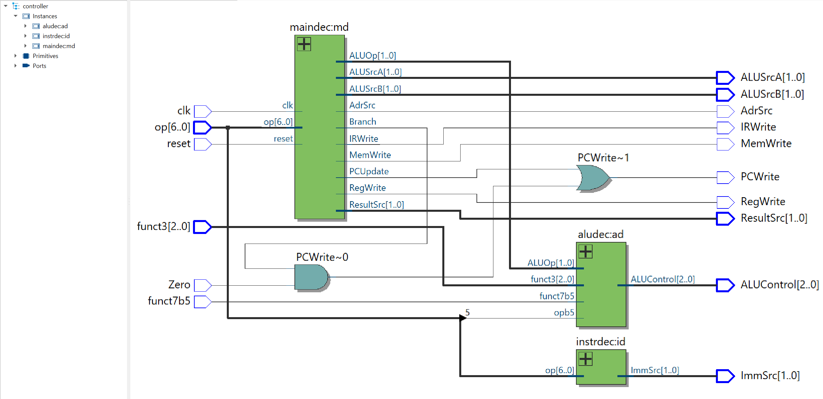
Figure 1 RTL Schematic

File: controller.sv
/*  Egemen Celik 2220357034  ELE432 HomeWork 2 : Multicycle_Processor_Controller  controller.sv  code modified from Harris&Harris book  */  module controller (  input logic clk,  input logic reset,  input logic [6:0] op,  input logic [2:0] funct3,  input logic funct7b5,  input logic Zero,  output logic [1:0] ImmSrc,  output logic [1:0] ALUSrcA, ALUSrcB,  output logic [1:0] ResultSrc,  output logic AdrSrc,  output logic [2:0] ALUControl,  output logic IRWrite, PCWrite,  output logic RegWrite, MemWrite  );  // internal wires  logic Branch;  logic PCUpdate;  logic [1:0] ALUOp;  assign PCWrite = (Zero & Branch) | PCUpdate; | // decoder logic  maindec md (  clk,  reset,  op,  Branch,  PCUpdate,  ALUSrcA,  ALUSrcB,  ResultSrc,  AdrSrc,  IRWrite,  RegWrite,  MemWrite,  ALUOp  );  aludec ad (  op[5],  funct3,  funct7b5,  ALUOp,  ALUControl  );  instrdec id (  op,  ImmSrc  );  endmodule

File: maindec.sv
/* Egemen Celik 2220357034  ELE432 HomeWork 2 : Multicycle_Processor_Controller  maindec.sv */  module maindec (  input logic clk,  input logic reset,  input logic [6:0] op,  output logic Branch,  output logic PCUpdate,  output logic [1:0] ALUSrcA,  output logic [1:0] ALUSrcB,  output logic [1:0] ResultSrc,  output logic AdrSrc,  output logic IRWrite,  output logic RegWrite,  output logic MemWrite,  output logic [1:0] ALUOp  );  // State encoding  typedef enum logic [3:0] {  S0_FETCH = 4'b0000,  S1_DECODE = 4'b0001,  S2_MEMADR = 4'b0010,  S3_MEMREAD = 4'b0011,  S4_MEMWB = 4'b0100,  S5_MEMWRITE = 4'b0101,  S6_EXECUTER = 4'b0110,  S7_ALUWB = 4'b0111,  S8_EXECUTEI = 4'b1000,  S9_JAL = 4'b1001,  S10_BEQ = 4'b1010  } state_t;  // State variables  state_t current_state, next_state;  // Opcode definitions  localparam logic [6:0] OP_LW = 7'b0000011;  localparam logic [6:0] OP_SW = 7'b0100011;  localparam logic [6:0] OP_RTYPE = 7'b0110011;  localparam logic [6:0] OP_ITYPE = 7'b0010011;  localparam logic [6:0] OP_JAL = 7'b1101111;  localparam logic [6:0] OP_BEQ = 7'b1100011;  // Sequential State transition logic  always_ff @(posedge clk or posedge reset) begin : Sequential_State  if (reset) current_state <= S0_FETCH;  else current_state <= next_state;  end  // Combinational State transition logic  always_comb begin : Combinational_State  // Default values  next_state = current_state;  case (current_state)  S0_FETCH: next_state = S1_DECODE;  S1_DECODE:  case (op)  OP_LW, OP_SW: next_state = S2_MEMADR;  OP_RTYPE: next_state = S6_EXECUTER;  OP_ITYPE: next_state = S8_EXECUTEI;  OP_JAL: next_state = S9_JAL;  OP_BEQ: next_state = S10_BEQ;  default: next_state = S0_FETCH;  endcase  S2_MEMADR:  case (op)  OP_LW: next_state = S3_MEMREAD;  OP_SW: next_state = S5_MEMWRITE;  default: next_state = S0_FETCH;  endcase  S3_MEMREAD: next_state = S4_MEMWB;  S4_MEMWB, S5_MEMWRITE, S7_ALUWB, S10_BEQ: next_state = S0_FETCH;  S6_EXECUTER, S8_EXECUTEI, S9_JAL: next_state = S7_ALUWB;  default: next_state = S0_FETCH;  endcase  end | // Output logic  always_comb begin : Outputs  // Default values  Branch = 1'b0;  PCUpdate = 1'b0;  ALUSrcA = 2'b00;  ALUSrcB = 2'b00;  ResultSrc = 2'b00;  AdrSrc = 1'b0;  IRWrite = 1'b0;  RegWrite = 1'b0;  MemWrite = 1'b0;  ALUOp = 2'b00;  case (current_state)  S0_FETCH: begin  AdrSrc = 1'b0;  IRWrite = 1'b1;  ALUSrcA = 2'b00;  ALUSrcB = 2'b10;  ALUOp = 2'b00;  ResultSrc = 2'b10;  PCUpdate = 1'b1;  end  S1_DECODE: begin  ALUSrcA = 2'b01;  ALUSrcB = 2'b01;  ALUOp = 2'b00;  end  S2_MEMADR: begin  ALUSrcA = 2'b10;  ALUSrcB = 2'b01;  ALUOp = 2'b00;  end  S3_MEMREAD: begin  ResultSrc = 2'b00;  AdrSrc = 1'b1;  end  S4_MEMWB: begin  ResultSrc = 2'b01;  RegWrite = 1'b1;  end  S5_MEMWRITE: begin  ResultSrc = 2'b00;  AdrSrc = 1'b1;  MemWrite = 1'b1;  end  S6_EXECUTER: begin  ALUSrcA = 2'b10;  ALUSrcB = 2'b00;  ALUOp = 2'b10;  end  S7_ALUWB: begin  ResultSrc = 2'b00;  RegWrite = 1'b1;  end  S8_EXECUTEI: begin  ALUSrcA = 2'b10;  ALUSrcB = 2'b01;  ALUOp = 2'b10;  end  S9_JAL: begin  ALUSrcA = 2'b01;  ALUSrcB = 2'b10;  ALUOp = 2'b00;  ResultSrc = 2'b00;  PCUpdate = 1'b1;  end  S10_BEQ: begin  ALUSrcA = 2'b10;  ALUSrcB = 2'b00;  ALUOp = 2'b01;  ResultSrc = 2'b00;  Branch = 1'b1;  end  endcase  end  endmodule

3) The controller.tv file was using a RISC-V standard different that the one in the Harris & Harris book and the homework file. I updated the expected ALUControl bits to match the Harris & Harris’s description. The updated file can be found in the GitHub repository.
Example:
//op[6:0]_funct3[2:0]_funct7b5_Zero_ImmSrc[1:0]_ALUSrcA[1:0]_ALUSrcB[1:0]_ResultSrc[1:0]_AdrSrc_ALUControl[2:0]_IRWrite_PCWrite_RegWrite_MemWrite
// add
old | updated
0110011_000_0_0__XX_00_10_10_0_010_1_1_0_0 // Fetch  0110011_000_0_0__XX_01_01_00_0_010_0_0_0_0 // Decode 0110011_000_0_0__XX_10_00_00_0_010_0_0_0_0 // ExecuteR 0110011_000_0_0__XX_00_00_00_0_010_0_0_1_0 // ALUWB | 0110011_000_0_0__XX_00_10_10_0_000_1_1_0_0 // Fetch  0110011_000_0_0__XX_01_01_00_0_000_0_0_0_0 // Decode  0110011_000_0_0__XX_10_00_00_0_000_0_0_0_0 // ExecuteR  0110011_000_0_0__XX_00_00_00_0_000_0_0_1_0 // ALUWB

Testbench Waveform Output:
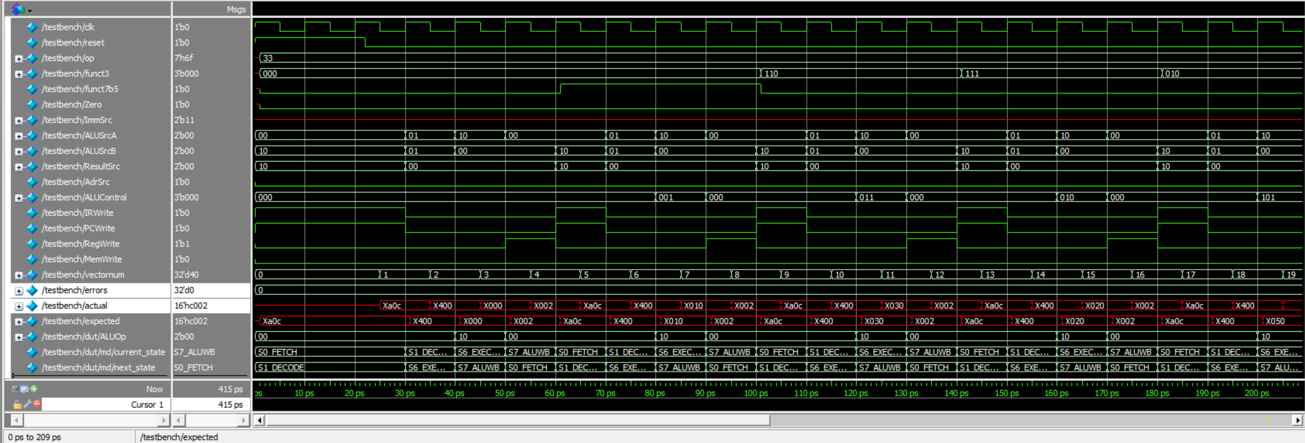
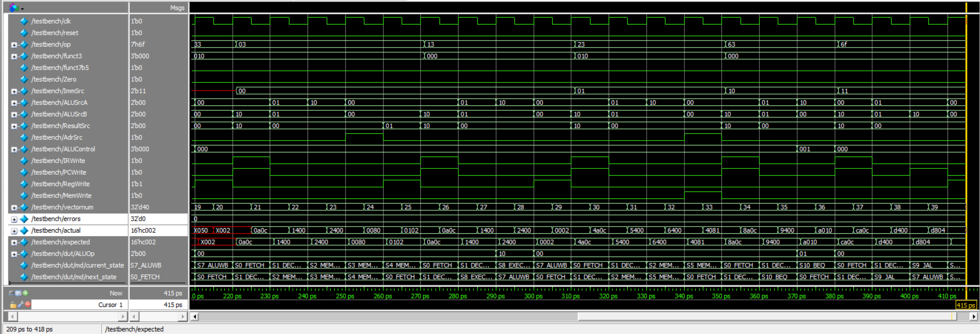

Questa Transcript Output:
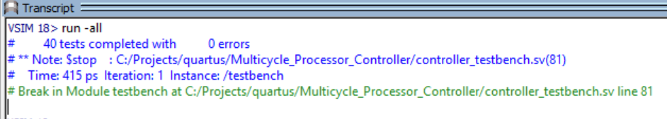

As you can see after the issue with the ALUControl bits is resolved there are no errors and everything works as expected.

4) The whole Quartus project directory along with all of the files of interest are uploaded inside separate folders along with this file in both Word and PDF forms.

GitHub link: https://github.com/20egemen04/Multicycle_Processor_Controller

